Conductors and Insulators

Electricity can pass through some materials and not others. Materials which electricity can pass through are called conductors, and materials which it cannot pass through are called insulators.

**Aim**: To test different materials for their electrical conductivity.

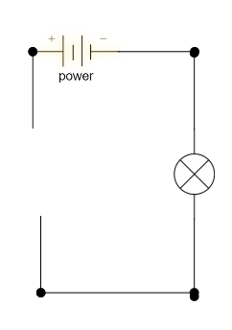

**Equipment**: Power pack **Diagram of Equipment Set-up**

1 x banana-banana lead

2 x banana-alligator leads

Light bulb in holder

Various substances

**Method**:

1. Plug one end of the banana-banana lead into one DC socket of the power pack and the other end into the light bulb holder.
2. Plug the banana end of a banana-alligator lead into the other DC socket of the power pack.
3. Plug the banana end of the other banana-alligator lead into the light bulb.
4. Plug the power pack into the wall and switch it on at the wall.
5. Test your light bulb is working by connecting the two alligator leads to complete the circuit.
6. Test each material by connecting it between two alligator clips and record the results below.

|  |  |  |
| --- | --- | --- |
| **Material** | **Will it conduct electricity?** | **Did it conduct electricity?** |
| Chalk |  |  |
| Glass |  |  |
| Aluminium |  |  |
| Copper |  |  |
| Rubber |  |  |
| Wood |  |  |
| Zinc |  |  |
| Plastic |  |  |
| Coal |  |  |
| Fabric |  |  |

**Results**:

**Questions**:

1. Which materials are conductors?
2. Which materials are insulators?
3. What do the materials which conduct electricity have in common?
4. What do the materials which do not conduct electricity have in common?
5. The tools electricians use are metal with a plastic handles. Suggest a reason for this.